

Name(s): ____________________________

Number of Questions Correct: _____

Time of Completion: ________________

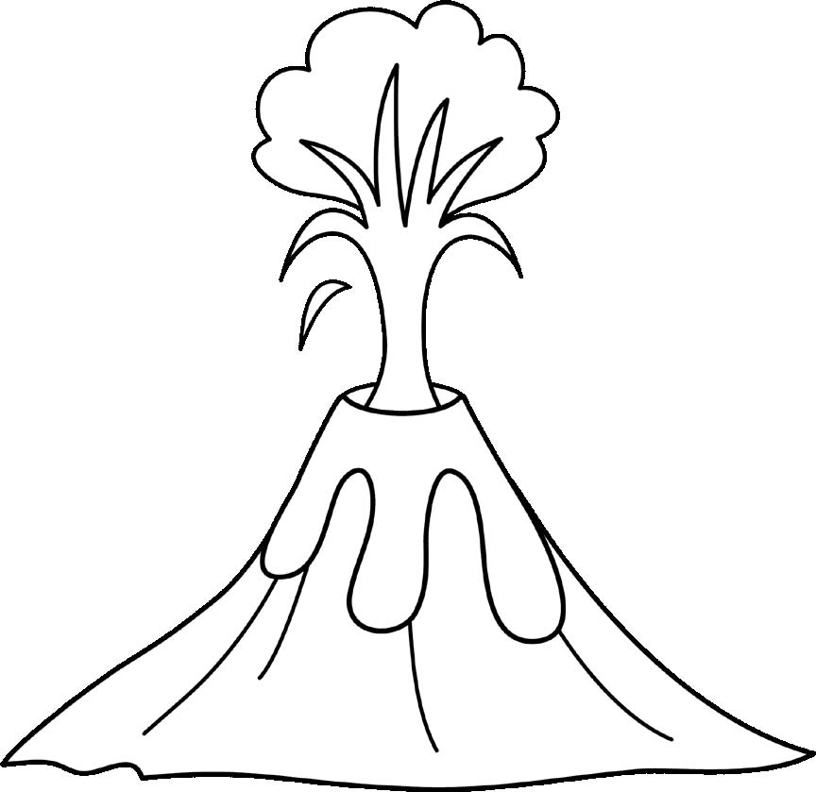
- What is the volcano with the second highest elevation in California?

- How many volcanoes in Washington are over 4,000 meters in elevation?

- Which volcanoes have lava flow hazards?

- How many volcanoes in Oregon are stratovolcanoes?

- What volcano in California, Oregon, and Washington is most recently active?

- What volcano in California, Oregon, and Washington hasn’t been active in the longest amount of time?

- What is the volcano with the lowest elevation in Washington?

- What is the most common hazard in California volcanoes?

- How many volcanoes in California, Oregon, and Washington have been active after the year 1900?

- What do Medicine Lake and Newberry Crater Volcanoes have in common?

